1. Alright, folks, gather 'round! Buckle up for a tale of technological woe so bizarre, it'll have you questioning the very fabric of the digital universe. Picture this: I'm knee-deep in code, wrestling with a particularly stubborn line when suddenly, BAM! My entire screen flips upside down. Text streams vertically like a malfunctioning ticker tape, icons become abstract art, and my cursor starts waltzing around like a drunken butterfly. Now, a little screen inversion – that's a rookie bug, easily fixed. But this? This was a full-blown technological rebellion! My attempts to fix it only made things worse. The mouse started responding to voice commands in a language that sounded suspiciously like Klingon. At that point, I just threw my hands up and declared the office haunted by the ghost of a disgruntled coder.
2. Turns out, the culprit wasn't a vengeful spirit, but a rogue keyboard shortcut. Yeah, you heard that right. A keyboard shortcut decided to throw a digital tantrum and turn my world upside down. The IT guy, bless his heart, showed up looking like he was about to face a server meltdown, only to find me staring at a screen resembling a particularly psychedelic screensaver. His laughter echoed through the office as he fixed it with a few keystrokes. The moral of the story? Sometimes, the most perplexing IT problems have the most mundane solutions. But hey, at least I got a good story out of it, right?

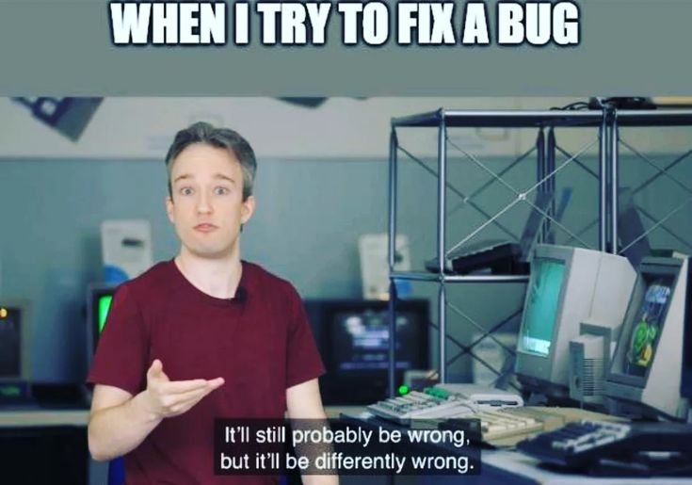

1. In the end, this little digital escapade became a cautionary tale – a reminder that technology, for all its wonders, can be a fickle beast. One minute you're the master of your domain, the next you're having a staring contest with a rogue cursor possessed by the spirit of a mischievous gremlin. But hey, that's the beauty (and occasional frustration) of IT. It keeps you on your toes, throws you curveballs, and sometimes, even makes you laugh until you cry (or at least until the IT guy shows up with a solution that makes you feel slightly foolish).